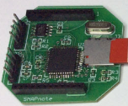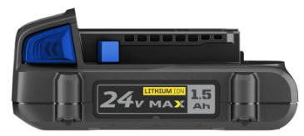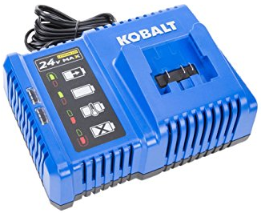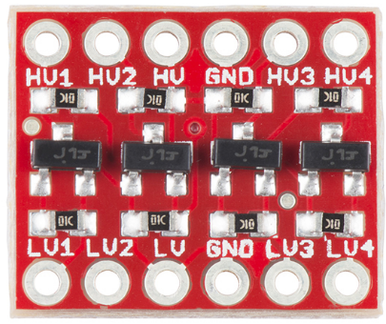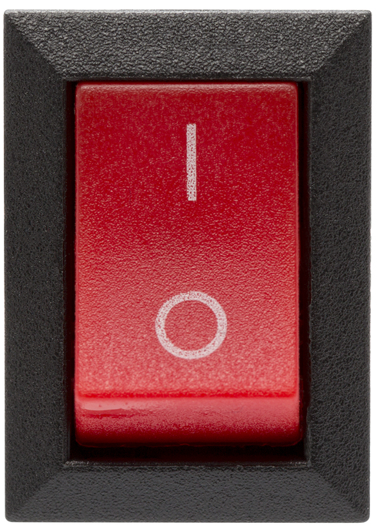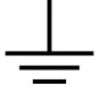

P19

P20

S1

S2

S3

S4

S5

S6

**3.3V**

**5V**

**24V**

S7

S8

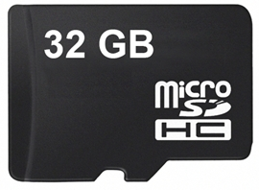

**3.3V**

P21

P22

P20

P21

P22

P19

P2

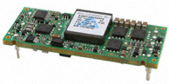

P2

P3

P3

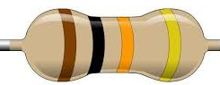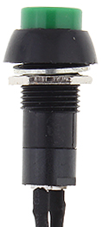

P10

10K

Connector

CPU 1

CPU 2



To LEDs

Power

Mode

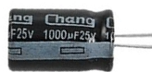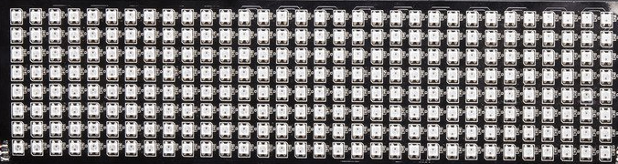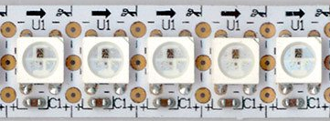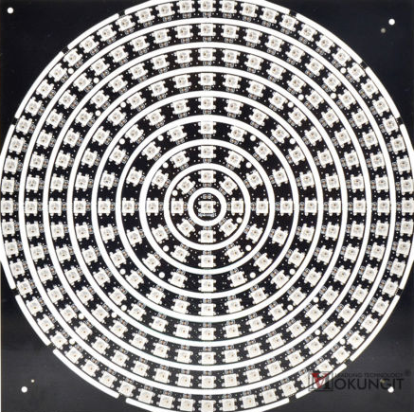

**5V**

S1

S3

S2

S4

S5

S6

S7

S8

241 pixels in the center of the top.

Four grids around the body. Each grid is 32*8 = 256 pixels.

54 pixels in short strips filling out the long axis of the top.

64 strips of 9 pixels wrapped around the brim. Divided into 2 sets of 288 pixels.

54 + 241 + 256*4 + 288*2 = 1895 total pixels